# DISTANCE MEASUREMENT AND OBJECT DETECTION SYSTEM USING ULTRASONIC SENSOR WITH RASPBERRY PI PICO W

### TEAM MEMBERS

### MOHAMED ASHAAN S

* SANTHOSHKUMAR S
* RAGUL E
* PRADEEBAN S

### Aim

To design and implement a distance measurement and object detection system using the HC-SR04 ultrasonic sensor interfaced with a Raspberry Pi Pico W. The system will display the real-time distance on an I2C LCD screen and provide a visual alert using an LED when an object is detected within a specific range.

### Apparatus Required

* Raspberry Pi Pico W
* HC-SR04 Ultrasonic Sensor Module
* I2C LCD Display Module (16x2)
* Breadboard
* Jumper Wires

### PIN TABLE

|  |  |
| --- | --- |
| Component Pin | Raspberry Pi Pico W Pin |
| HC-SR04 VCC | 5V (VBUS) |
| HC-SR04 GND | GND |
| HC-SR04 Trig | GPIO 3 |
| HC-SR04 Echo | GPIO 2 |
| I2C LCD VCC | 3.3V |
| I2C LCD GND | GND |
| I2C LCD SDA | GPIO 4 |
| I2C LCD SCL | GPIO 5 |

### COMPONENT DESCRIPTIONS

### Raspberry Pi Pico W

The Raspberry Pi Pico W is a low-cost, high-performance microcontroller board featuring a dual-core processor. It includes built-in Wi-Fi and Bluetooth capabilities, making it ideal for a wide range of IoT applications, embedded systems, and hobbyist projects. Its GPIO pins allow for easy interfacing with various sensors and modules.

### HC-SR04 Ultrasonic Sensor

The HC-SR04 is a non-contact distance measurement sensor. It operates by transmitting an ultrasonic pulse and measuring the time it takes for the echo to return. The distance to an object is calculated based on this time interval and the speed of sound. It is commonly used in robotics for obstacle avoidance and in automation projects for object detection.

### I2C LCD Display

An I2C LCD (Liquid Crystal Display) module is a screen used for displaying text and simple graphics. This 16x2 version can display two rows of 16 characters. By using the I2C communication protocol, it simplifies wiring, requiring only two data lines (SDA and SCL) to connect to a microcontroller, in addition to power and ground.

### FLOW CHART

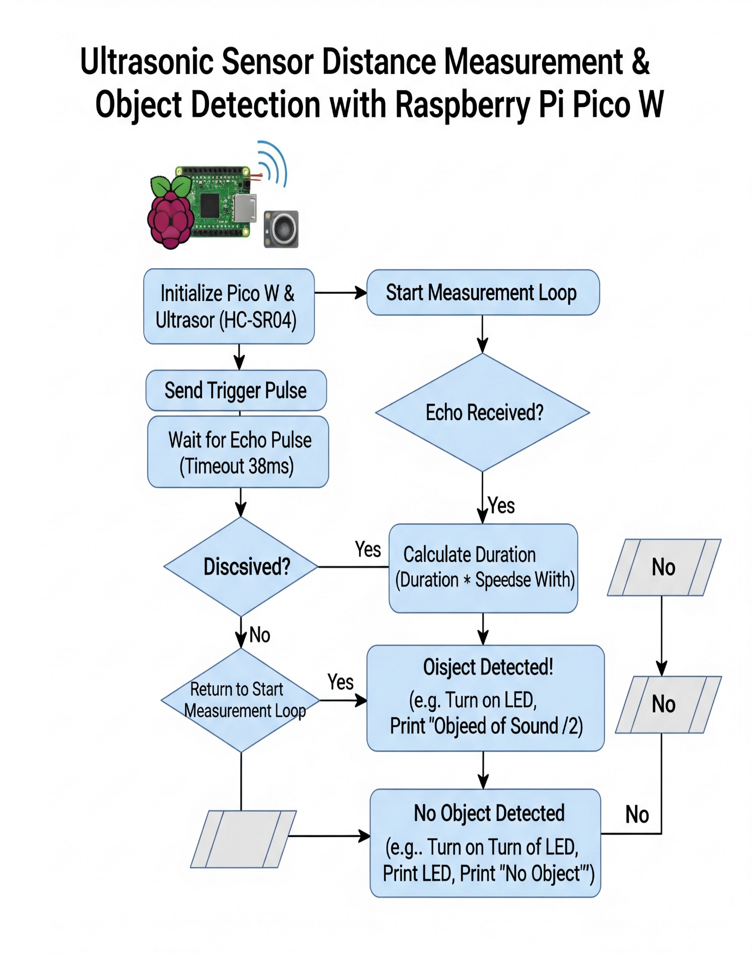

### PROGRAM

from machine import Pin, SoftI2C

import utime

from pico_i2c_lcd import I2cLcd

# Define the GPIO pins for the HC-SR04 ultrasonic sensor

trigger = Pin(3, Pin.OUT)

echo = Pin(2, Pin.IN)

# Define the built-in LED pin for proximity alerts

led = Pin(25, Pin.OUT) # Onboard LED on Raspberry Pi Pico W

# --- LCD Configuration ---

I2C_ADDR = 0x27       # I2C address of the LCD

I2C_NUM_ROWS = 2      # Number of rows on the LCD

I2C_NUM_COLS = 16     # Number of columns on the LCD

# Initialize I2C communication for the LCD

i2c = SoftI2C(sda=Pin(4), scl=Pin(5), freq=400000)

lcd = I2cLcd(i2c, I2C_ADDR, I2C_NUM_ROWS, I2C_NUM_COLS)

def measure_distance():

    """

    Triggers the ultrasonic sensor and measures the distance to an object.

    Returns the distance in centimeters.

    """

    # Send a short pulse to trigger the sensor

    trigger.low()

    utime.sleep_us(2)

    trigger.high()

    utime.sleep_us(5) # A 10us pulse is recommended, but 5us works well

    trigger.low()

    # Wait for the echo pin to go high, marking the start of the echo pulse

    while echo.value() == 0:

        pulse_start = utime.ticks_us()

    # Wait for the echo pin to go low, marking the end of the echo pulse

    while echo.value() == 1:

        pulse_end = utime.ticks_us()

    # Calculate the duration of the pulse

    pulse_duration = pulse_end - pulse_start

    # Calculate distance using the speed of sound (343 m/s or 0.0343 cm/µs)

    # The duration is divided by 2 because the pulse travels to the object and back.

    distance_cm = (pulse_duration * 0.0343) / 2

    return distance_cm

# --- Main Program Execution ---

# Display an initial message on the LCD

lcd.putstr("Measuring...")

utime.sleep(2)

lcd.clear()

try:

    # Main loop to continuously measure and display distance

    while True:

        distance = measure_distance()

        # Clear the LCD and display the new distance reading

        lcd.clear()

        lcd.putstr("Distance:\n{:.2f} cm".format(distance))

        # Check if an object is within the 10 cm threshold

        if distance < 10:

            led.value(1)  # Turn on the LED for alert

        else:

            led.value(0)  # Turn off the LED

        # Wait for 1 second before the next measurement

        utime.sleep(1)

except KeyboardInterrupt:

    # Clean up resources if the program is stopped manually (Ctrl+C)

    lcd.backlight_off()

    lcd.display_off()

    led.value(0) # Ensure LED is off on exit

    print("Program stopped.")

